CSA1506- Cloud Computing and Big Data Analytics
Name: K Sumanth Kumar Reddy
Reg No: 192425222
LAB PROGRAMS
12. Demonstrate virtualization by Installing Type-2 Hypervisor in your device, create and configure VM image with a Host Operating system (Either Windows/Linux).
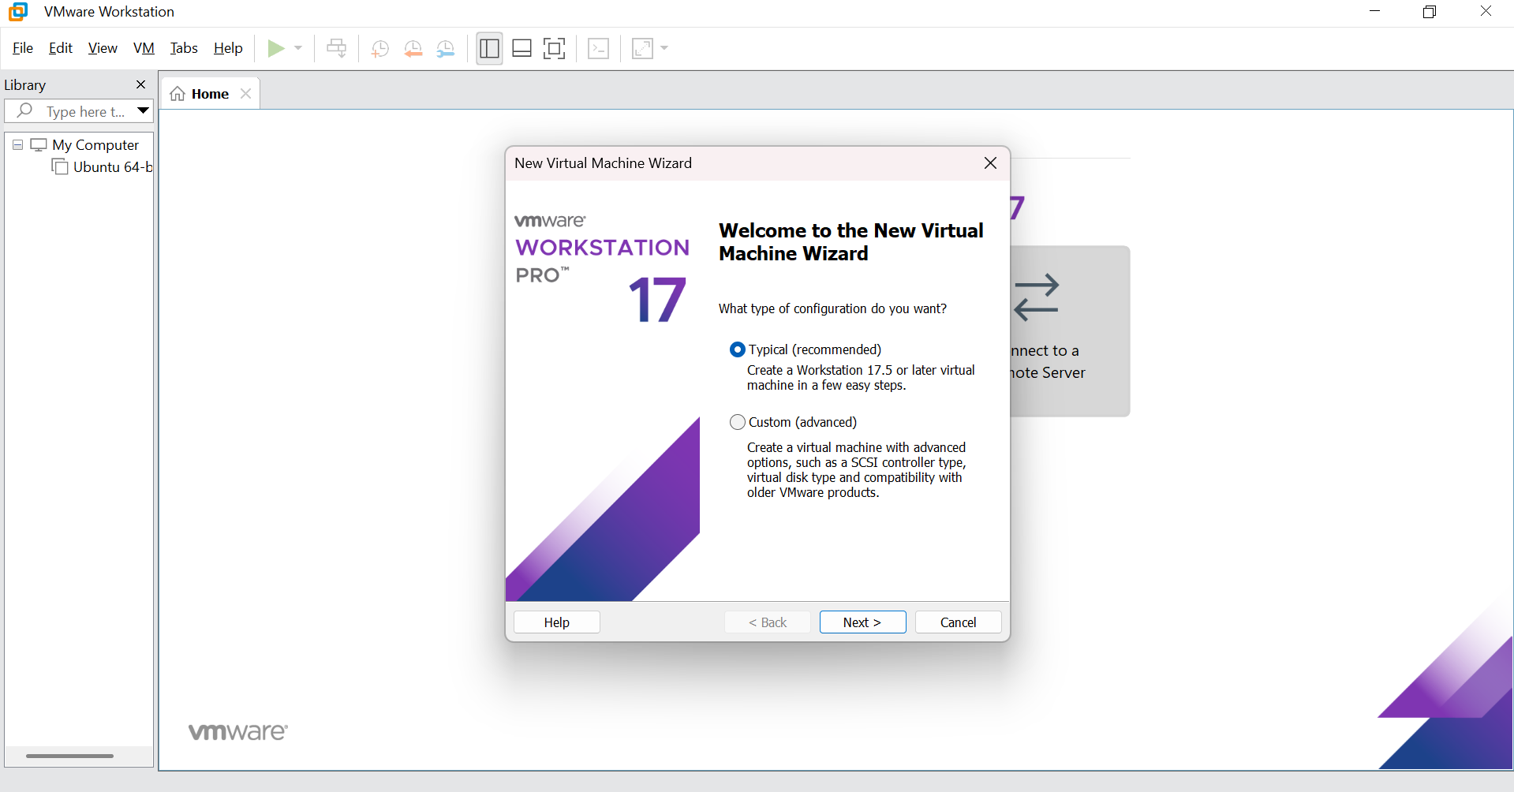

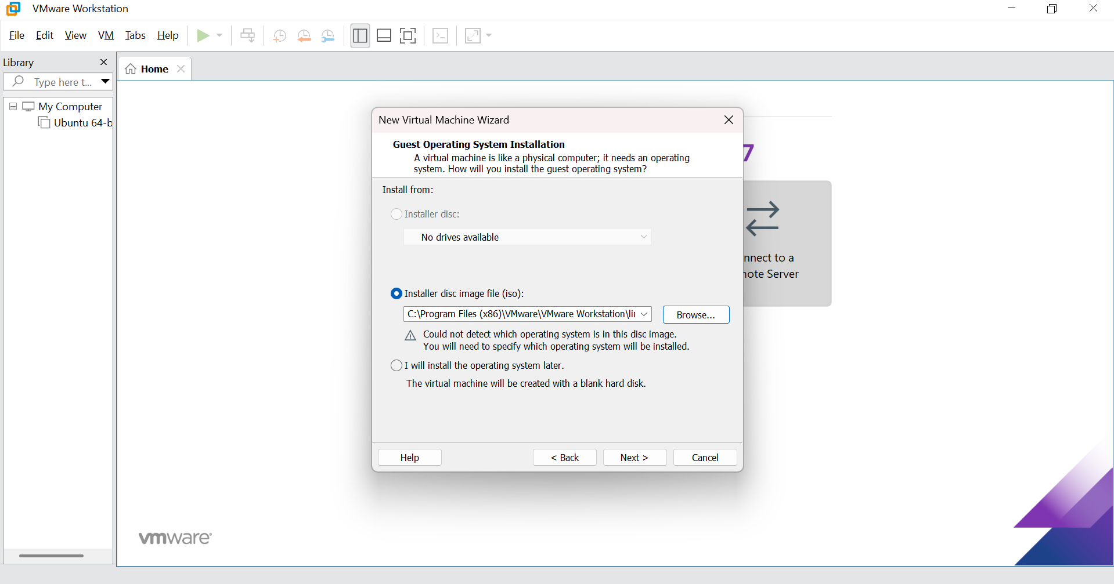

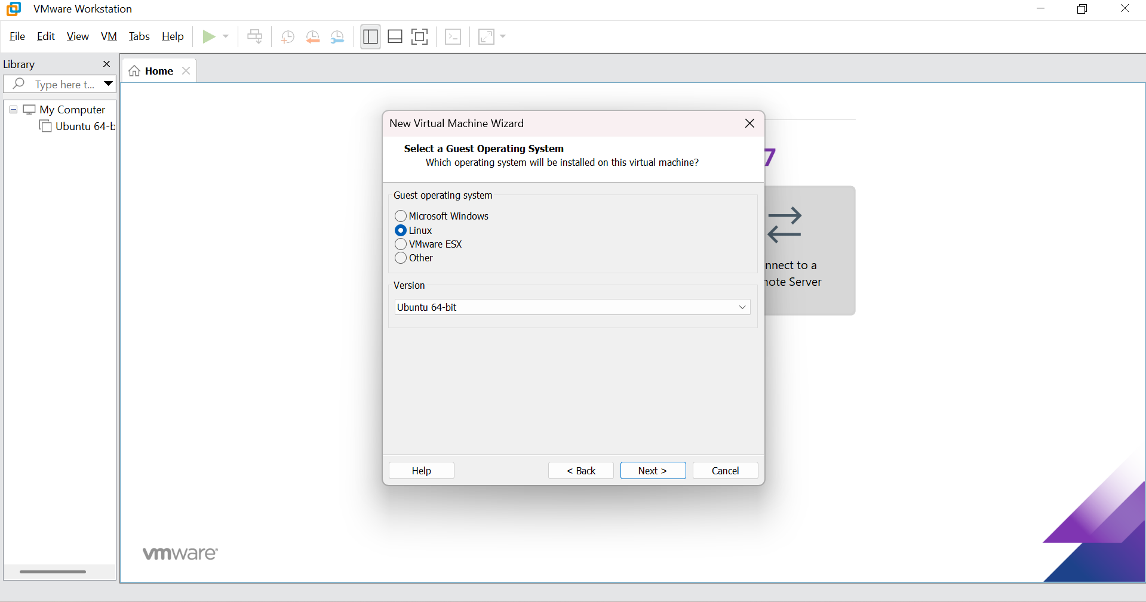
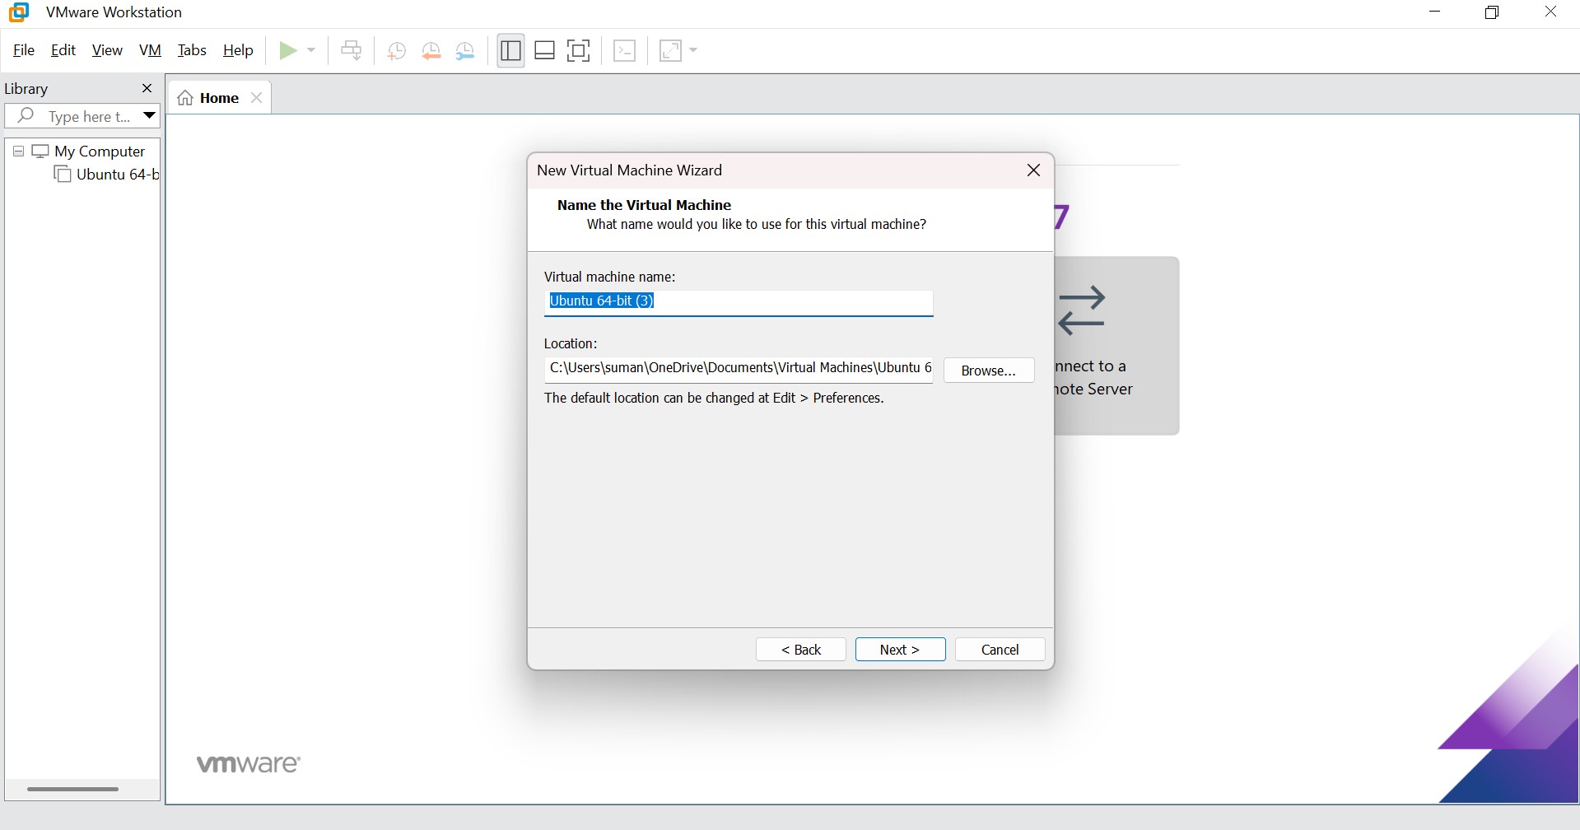
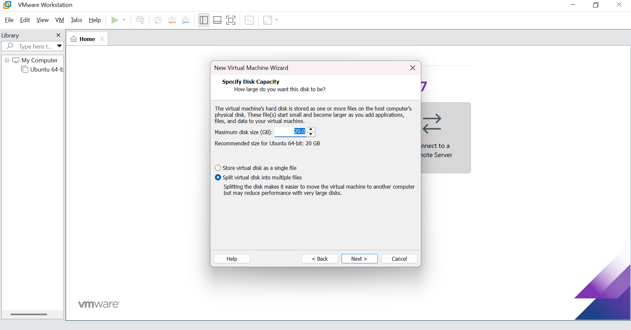
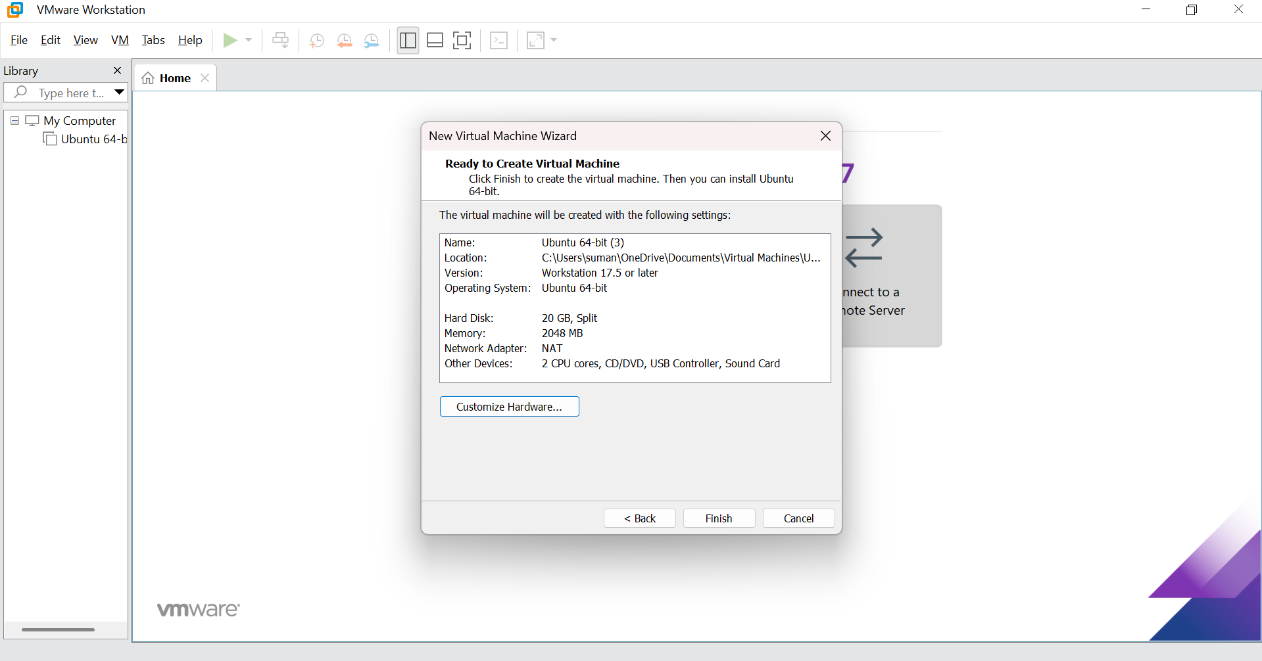

13. Create a Virtual Machine with 1 CPU, 2GB RAM and 15GB storage disk using a Type 2 Virtualization Software.
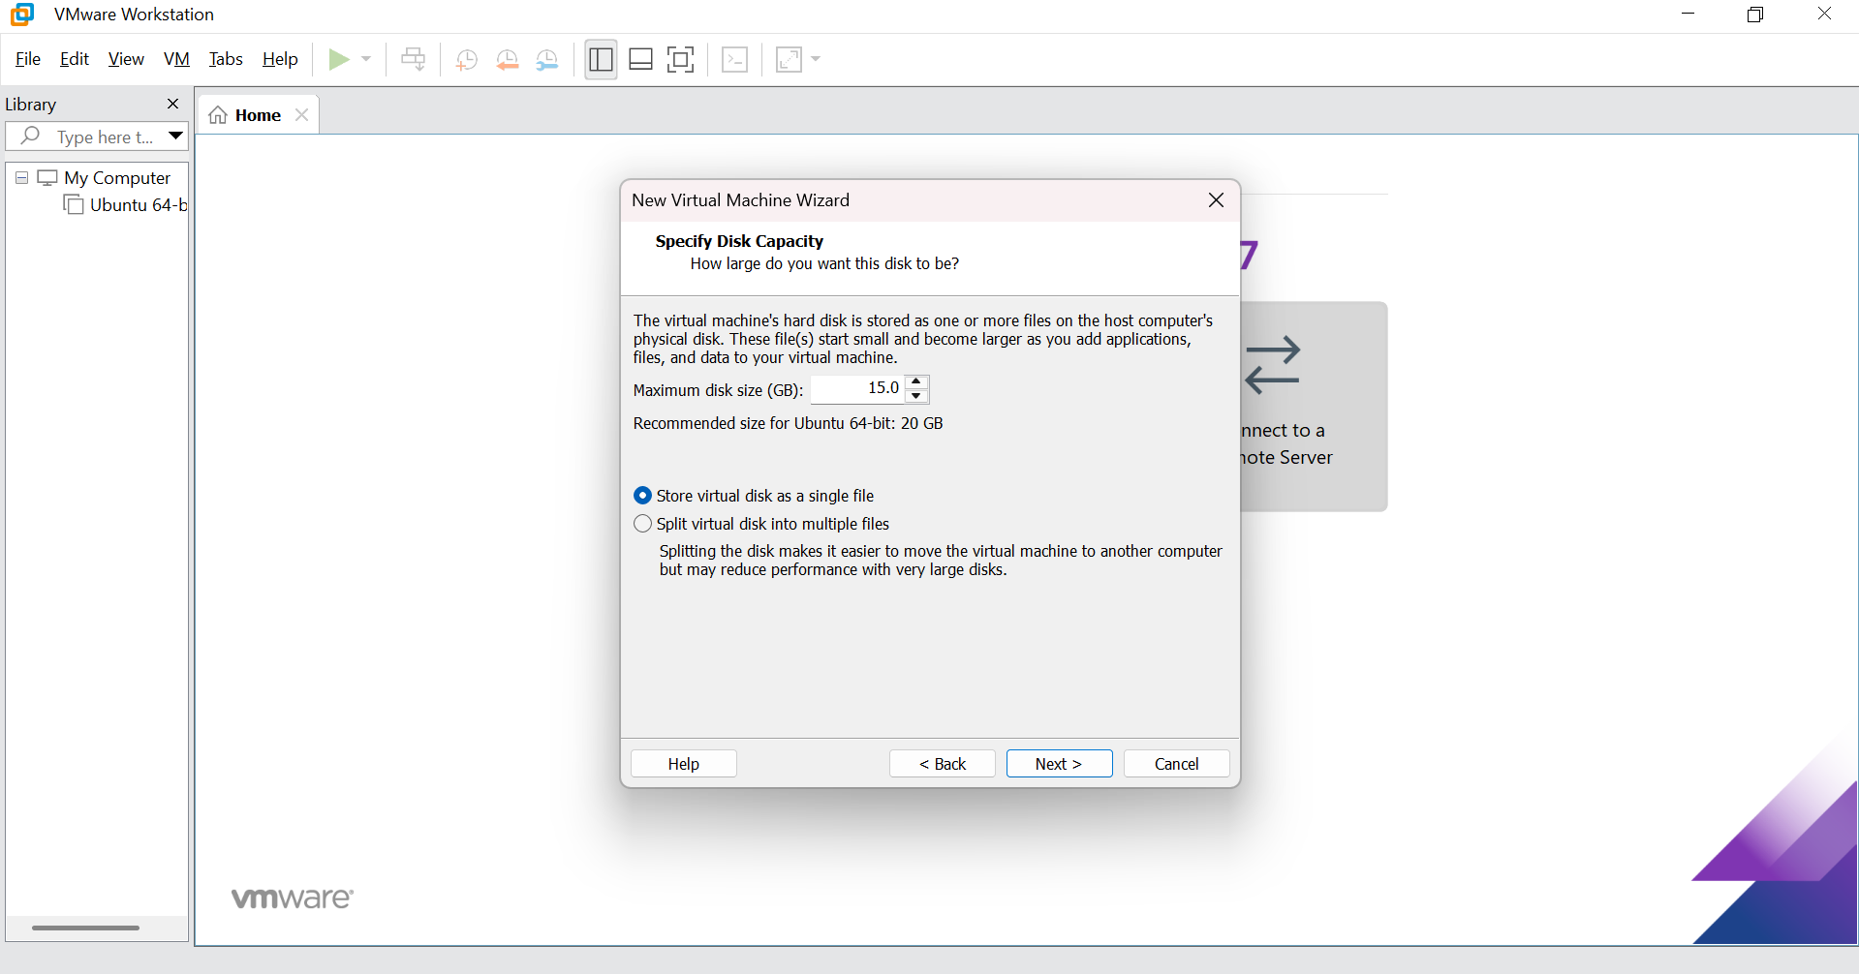

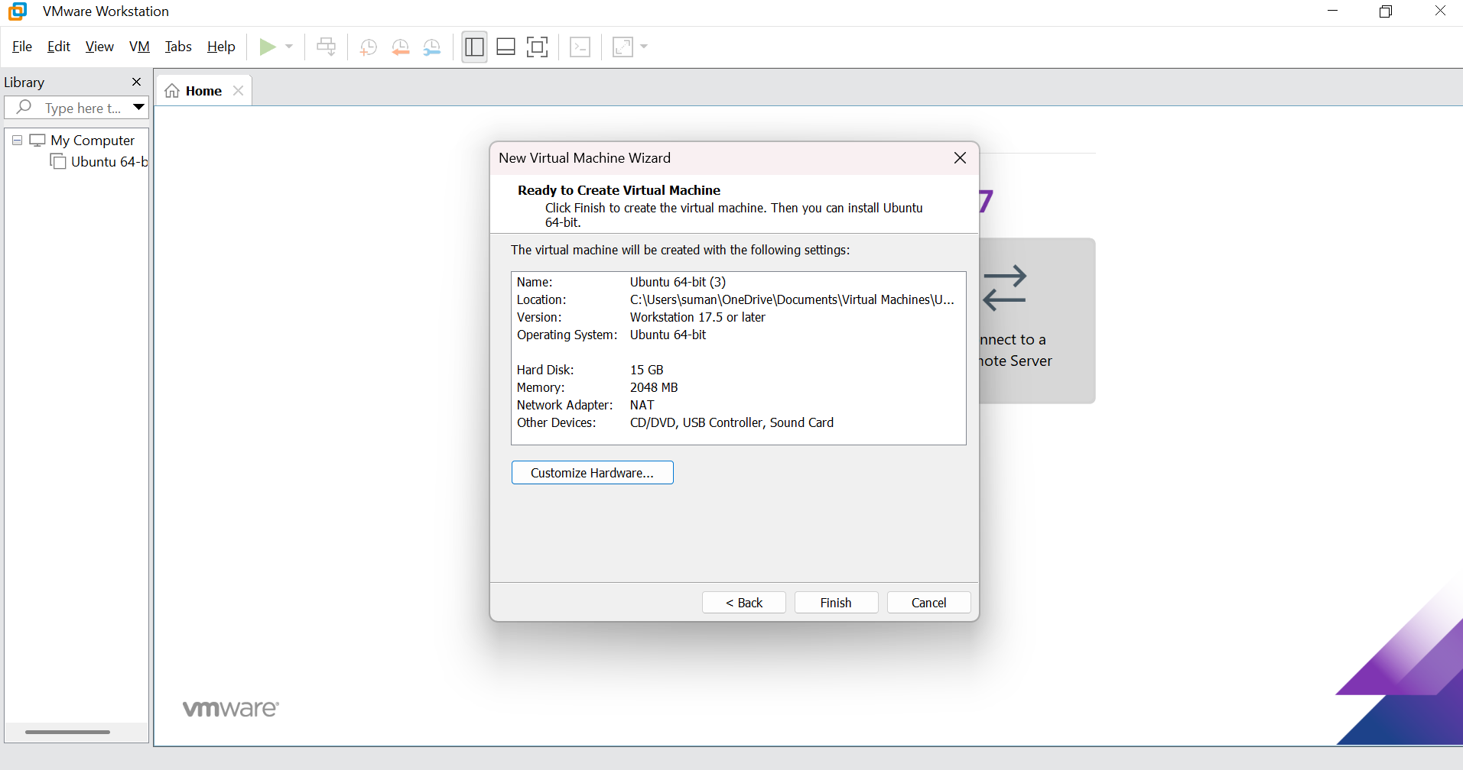

14. Create a Virtual Hard Disk and allocate the storage using VM ware Workstation
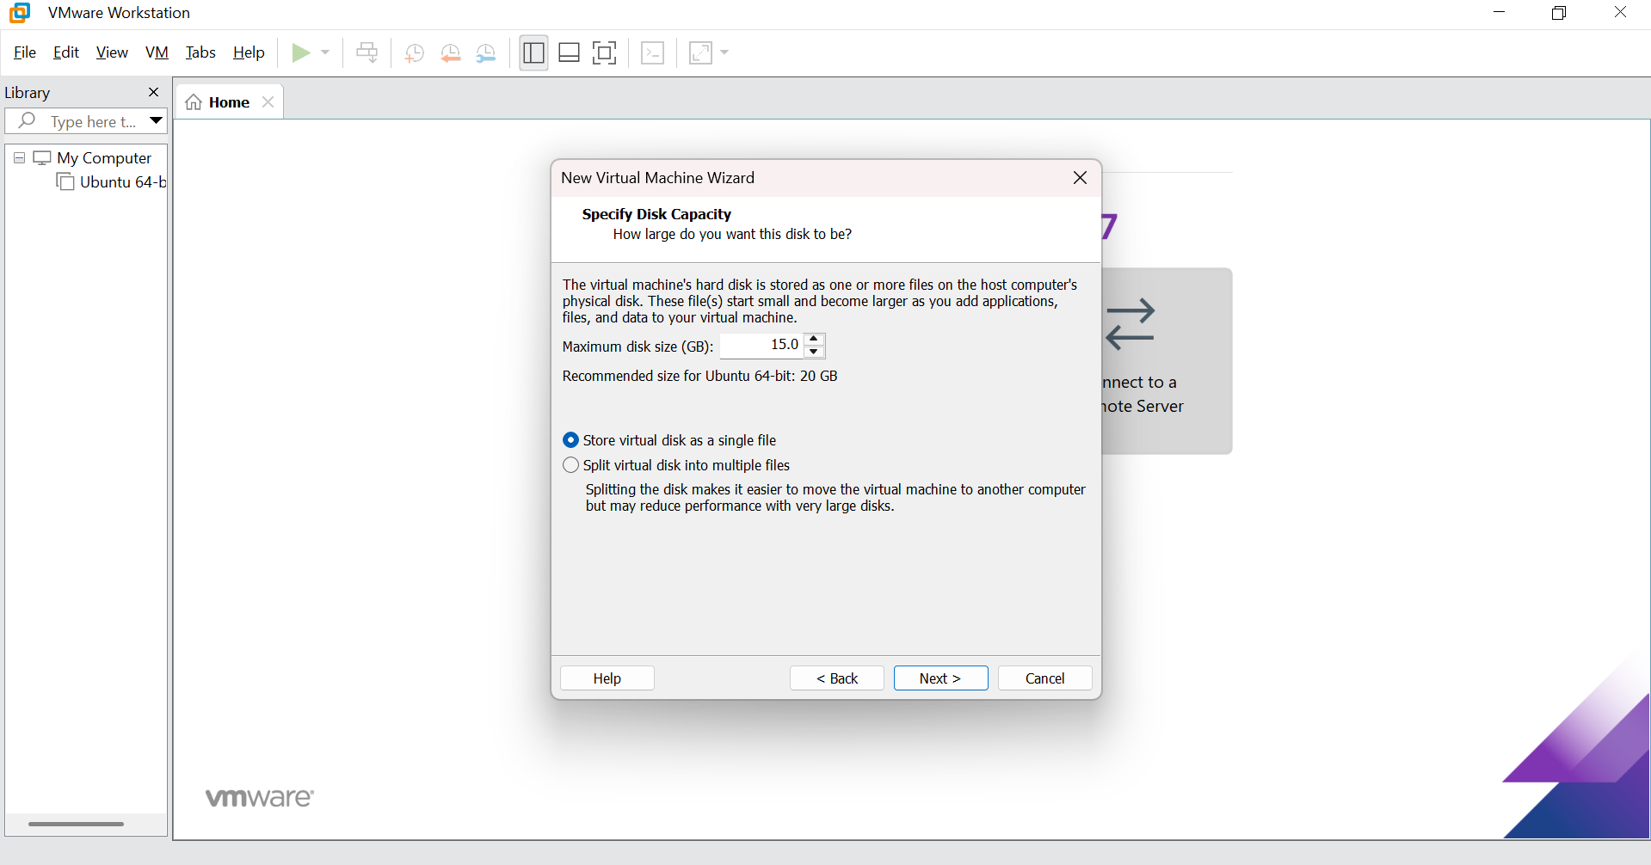

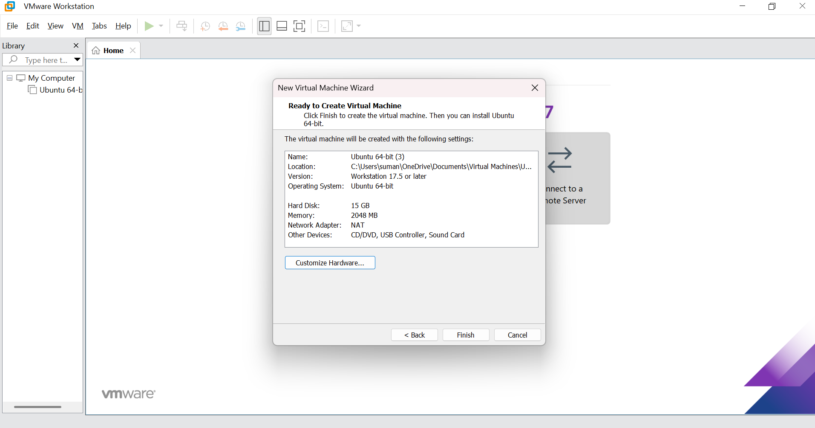

15. Create a Snapshot of a VM and Test it by loading the Previous Version/Cloned VM
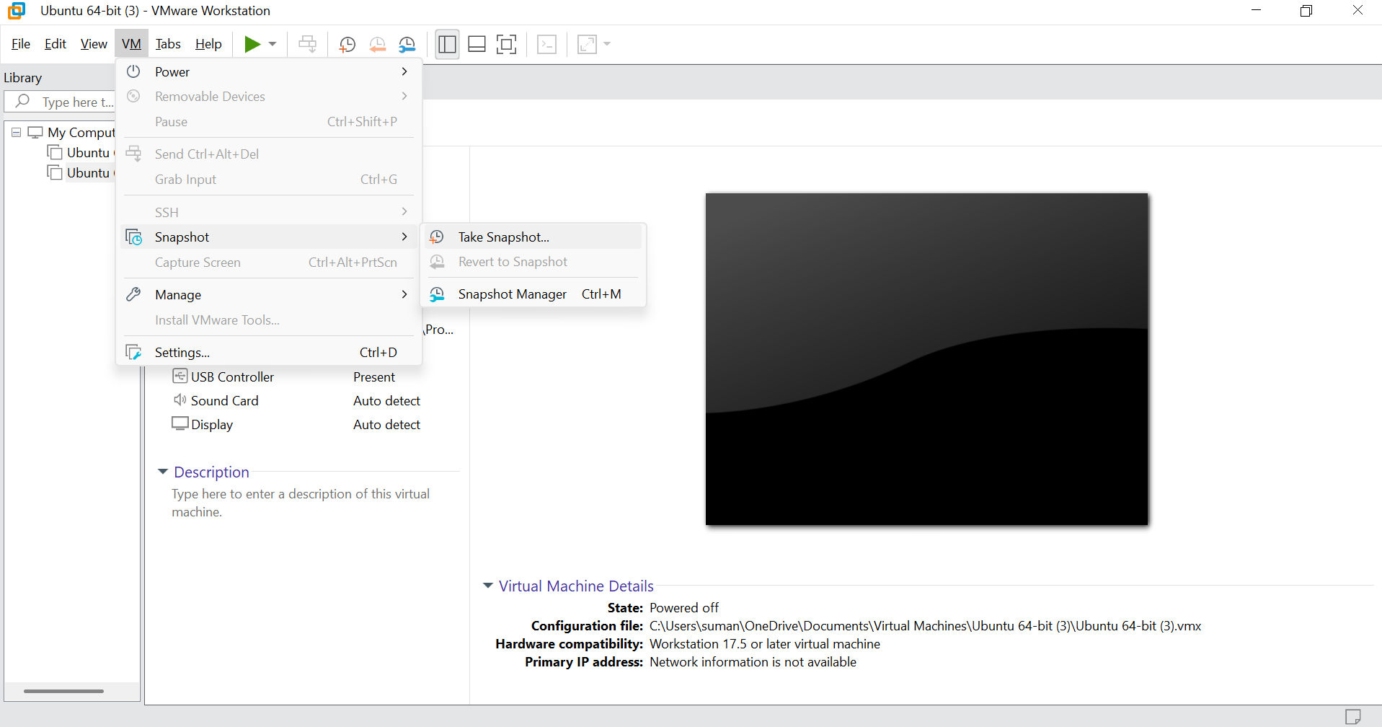

16. Create a Cloning of a VM and Test it by loading the Previous Version/Cloned VM
